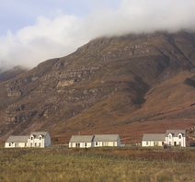 | COMMUNITY FUND  APPLICATION FORM
Name of Organisation: |  | Registered Address:
Applicant Name: |  | Address (if different from above):
Position: |  | Email/Telephone:
Geographical area covered:

Please give a brief description of what the organisation does:

Amount of funding requested (up to £500):

Please give a brief description of how the money will be used:

Signed: |  | Date:
Print Name:

Please return to:
Albyn Housing Society Ltd
FAO Mrs J Soley (Customer Services Manager South)
68 MacLennan Crescent
Inverness
IV3 8DN
jennifer.soley@albynhousing.org.uk

Please provide a scanned copy of your organisation’s Bank paying-in slip, as proof that you have a Bank account set up for the group.

